Test des différentes Balises

Nom : MORELLE
prénom : Geoffrey

Activité HTML : Test de balise
------------------------------------------------------------------------------------------------------------------------
Balise html, head, meta, title, body, h1, h2, h3, h4, h5 et h6 :

<!DOCTYPE html>
<html>
<head>
<meta charset='utf-8'>
<title>TP1 2</title>
</head>
<body>
<h1>Bienvenue TPD1</h1>
<h2>Bienvenue TPD1</h2>
<h3>Bienvenue TPD1</h3>
<h4>Bienvenue TPD1</h4>
<h5>Bienvenue TPD1</h5>
<h6>Bienvenue TPD1</h6>
</body>
</html>

Résultat :

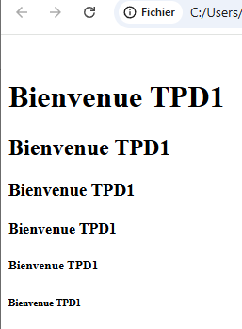

Balise img :

<!DOCTYPE html>
<html>
<head>
<meta charset='utf-8'>
<title>TP1 2</title>
</head>
<body>
<img src="https://upload.wikimedia.org/wikipedia/commons/8/89/Cumulus_cloud.jpg">
</body>
</html>

Résultat :

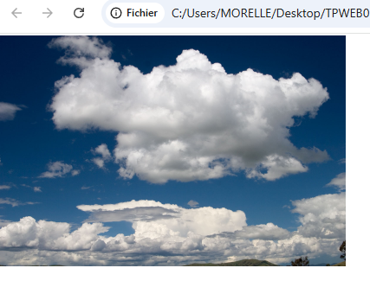

Balise meta :

<!DOCTYPE html>
<html>
<head>
<meta charset='utf-8'>
<title>TP1 2</title>
</head>
<body>
<meta http-equiv="refresh" content="3;https://images.unsplash.com/photo-1520209759809-a9bcb6cb3241?fm=jpg&q=60&w=3000&ixlib=rb-4.1.0&ixid=M3wxMjA3fDB8MHxzZWFyY2h8Mnx8aW1nfGVufDB8fDB8fHww">
</body>
</html>

Résultat :
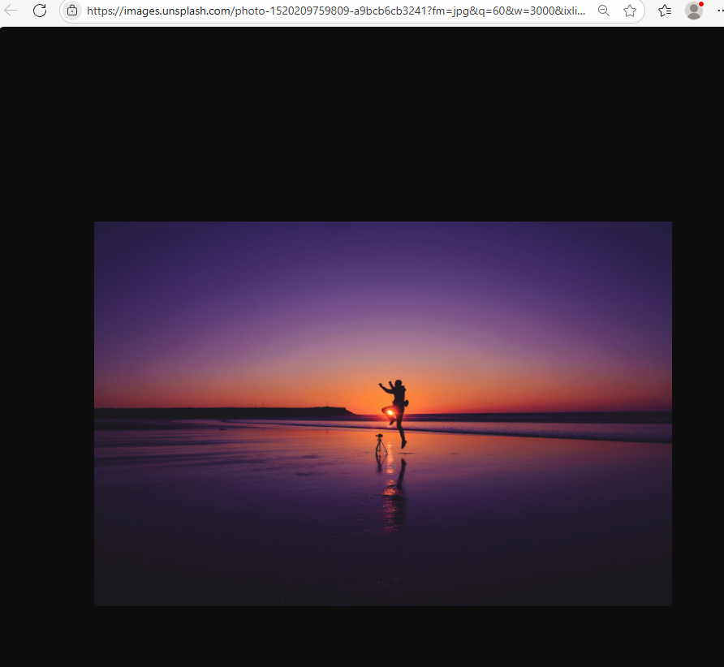
(Résultat obtenue 3 seconde après avoir ouvert le fichier HTML)

Balise p, div et link :

HTML :
<!DOCTYPE html>
<html>
<head>
<meta charset='utf-8'>
<link href="css.css" rel="stylesheet" type="text/css">
<title>TP1 2</title>
</head>
<body>
<p>Lorem ipsum dolor sit amet consectetur adipisicing elit. Necessitatibus quae aliquid sequi fugiat rem illo tenetur accusamus, fuga nemo officia suscipit eos eius eaque, ipsam, asperiores quo quos fugit. Possimus.</p>

<div class="shadowbox">
<p>Voici un paragraphe très intéressant inscrit dans une boîte avec une ombre.</p>
</div>

</body>
</html>

CSS :
p{
background-color: teal;
color: white;
}

.shadowbox {
width: 15em;
border: 1px solid #333;
box-shadow: 8px 8px 5px #444;
padding: 8px 12px;
background-image: linear-gradient(180deg, #fff, #ddd 40%, #ccc);
}

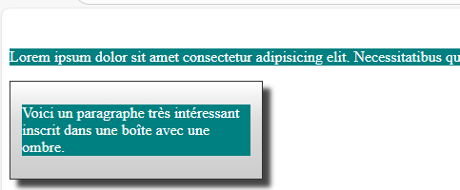

Résultat :

Balise script, hr et br :

HTML :
<!DOCTYPE html>
<html>
<head>
<meta charset='utf-8'>
<script type="text/javascript" src="JavaScript .js"></script>
<title>TP1 2</title>
</head>
<body>
<p>Lorem ipsum dolor sit amet consectetur adipisicing elit. Dolores ipsum recusandae eveniet facere, doloribus quis dolore quibusdam, ut error hic eius inventore repellendus qui, harum impedit. Aliquid dicta quos doloremque.</p>
<hr />
<p>Lorem ipsum dolor sit amet consectetur adipisicing elit. Necessitatibus quae aliquid sequi fugiat rem illo tenetur accusamus, fuga nemo officia suscipit eos eius eaque, ipsam, asperiores quo quos fugit. Possimus.</p>
<br>
<p>Lorem ipsum dolor, sit amet consectetur adipisicing elit. Laudantium necessitatibus obcaecati repudiandae accusamus, error voluptatem reprehenderit aliquid assumenda esse quisquam, repellendus illo fugit vel libero omnis minus consectetur quaerat hic.</p>
</body>
</html>

JavaScript :
function changeBackground(color) {
document.body.style.background = color;
}

window.addEventListener("load",function() { changeBackground('red') });

Résultat :
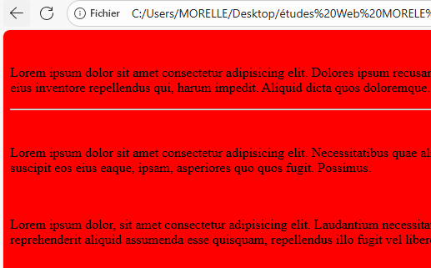

Balise a :

<!DOCTYPE html>
<html>
<head>
<meta charset='utf-8'>
<title>TP1 2</title>
</head>
<body>
<a href="https://developer.mozilla.org/fr/docs/Web/HTML"><p>documentation HTML</p></a>
</body>
</html>

Résultat :

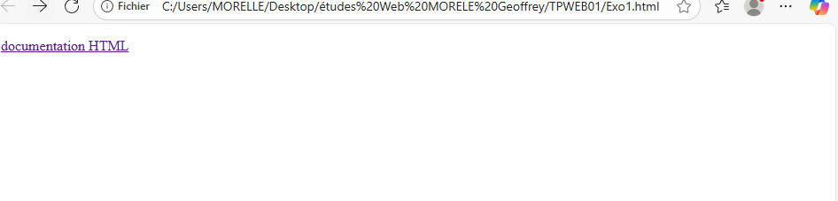
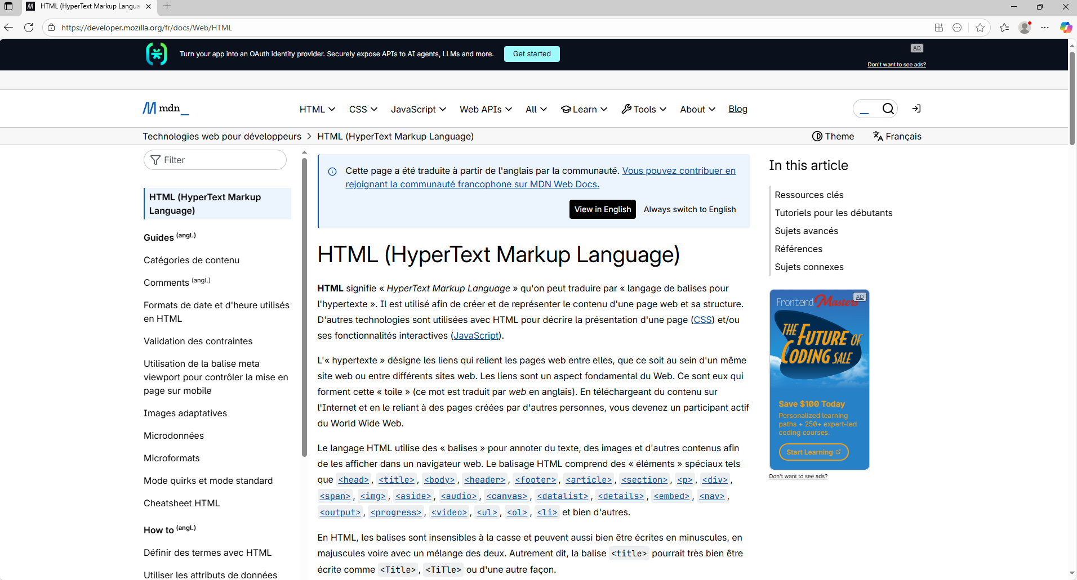
(Résultat quand on clique sur l’hypertexte « documentation HTML»)

Balise ul, ol et li :

<!DOCTYPE html>
<html>
<head>
<meta charset='utf-8'>
<title>TP1 2</title>
</head>
<body>
<ul>
<li>Lorem ipsum dolor sit amet consectetur adipisicing elit. Laboriosam maxime repudiandae reprehenderit. Iure, at delectus. Exercitationem, nihil minima deleniti dolorem at qui error inventore, sapiente eum dignissimos voluptates quo odio!</li>
<li>Lorem, ipsum dolor sit amet consectetur adipisicing elit. Nobis earum tempora esse facilis tenetur optio perferendis reiciendis qui vero minima, in hic iure odit praesentium quos? Quisquam necessitatibus aspernatur molestias.</li>
<li>Lorem ipsum dolor sit amet consectetur adipisicing elit. Recusandae repellendus dolores blanditiis molestias doloribus sunt beatae! Accusamus explicabo corrupti corporis aspernatur reiciendis repellendus deserunt dolor ullam, voluptas earum necessitatibus quidem.</li>
</ul>

<ol>
<li>Lorem ipsum dolor sit amet, consectetur adipisicing elit. Velit, recusandae! Incidunt ipsam, ea omnis rerum nobis quisquam aliquam eligendi. Numquam odit pariatur delectus soluta quo voluptatem rerum nulla quibusdam quasi.</li>
<li>Lorem ipsum dolor, sit amet consectetur adipisicing elit. Harum obcaecati illum hic. Inventore itaque cum incidunt reiciendis molestias hic rem magni aliquid fugiat, vero nemo, eveniet tempora ipsa dignissimos obcaecati!</li>
<li>Lorem ipsum dolor sit, amet consectetur adipisicing elit. In laboriosam optio expedita, ipsam, et quibusdam dolor nobis, tempore commodi totam excepturi eaque. Tempore facilis iste inventore et minus? Debitis, facilis?</li>
</ol>
</body>
</html>

Résultat :
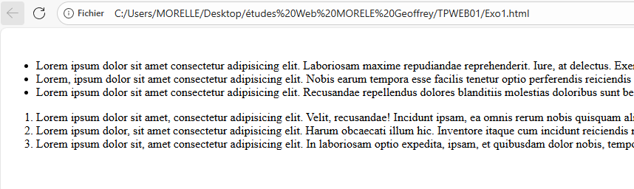
Balise table, tr, td et th :

<!DOCTYPE html>
<html>
<head>
<meta charset='utf-8'>
<title>TP1 2</title>
</head>
<body>
<table>
<tr>
<th scope="col">Person</th>
<th scope="col">Most interest in</th>
<th scope="col">Age</th>
</tr>
<tr>
<th scope="row">Chris</th>
<td><center>HTML tables</center></td>
<td><center>22</center></td>
</tr>
<tr>
<th scope="row">Dennis</th>
<td><center>Web accessibility</center></td>
<td><center>45</center></td>
</tr>
<tr>
<th scope="row">Sarah</th>
<td><center>JavaScript frameworks</center></td>
<td><center>29</center></td>
</tr>
<tr>
<th scope="row">Karen</th>
<td><center>Web performance</center></td>
<td><center>36</center></td>
</tr>
</table>
</body>
</html>
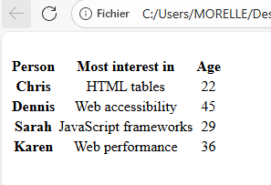
Résultat :

Balise span :

HTML :
<!DOCTYPE html>
<html>

<head>
<meta charset='utf-8'>

<link href="css.css" rel="stylesheet" type="text/css">
<title>TP1 2</title>
</head>
<body>
<p>autre texte <span>un peu de texte</span> etc...</p>
</body>
</html>

CSS :
p span {
background: green;
}

Résultat :

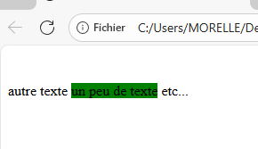

Balise from, input , textarea et button:

<!DOCTYPE html>
<html>

<head>
<meta charset='utf-8'>

<link href="css.css" rel="stylesheet" type="text/css">
<title>TP1 2</title>
</head>

<body>
<form method="post">
<label>Nom :
<input name="submitted-name" autocomplete="name" />
</label>
<button>Sauvegarder</button>
</form>

<textarea name="textarea" rows="10" cols="50">Vous pouvez écrire ici.</textarea>
</body>

</html>

Résultat :
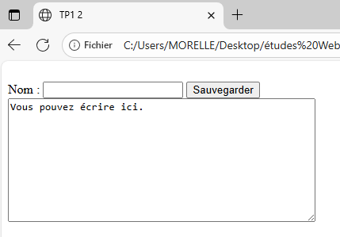
Balise blockquote, cite, em et strong:

<!DOCTYPE html>
<html>

<head>
<meta charset='utf-8'>
<title>TP1 2</title>
</head>

<body>
<div>
<blockquote cite="https://www.huxley.net/bnw/four.html">
<p>
<strong>can be like X-rays, if you use them properly—they’ll go through anything.</strong> You read and you’re pierced.
</p>
</blockquote>
<p><em>—Aldous Huxley, </em><cite>Brave New World</cite></p>
</div>
</body>

</html>

Résultat :

